DIRECT LINKS TO e-BOOK DOWNLOADS
If you click on the titles below, these volumes will open on your pc or laptop.

If you have an ipad or Mac, download the “ibooks”app (most should already have it), and then when you click on the link, you will have the option to open the title in ibooks, which will provide the optimal viewing experience.

 | 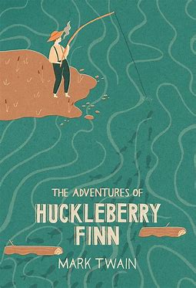 |  | 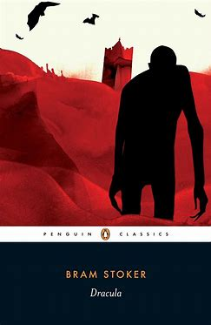
The Call of the Wild | The Adventures of Huckleberry FInn | A Tale of Two Cities | Dracula
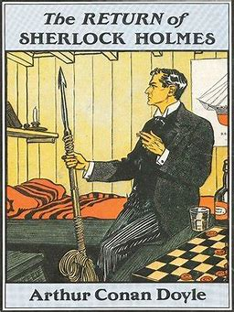 | 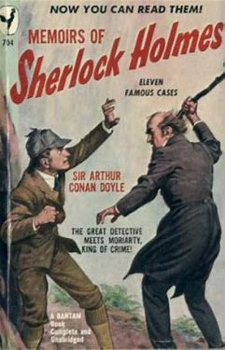 | 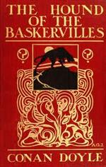
The Return of  Sherlock Holmes | The Memoirs of Sherlock Holmes | Hound of the Baskervilles | His Last Bow
 |  |  | 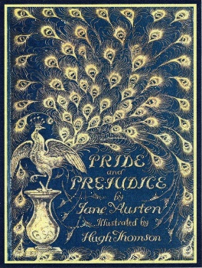
Dr. Jekyll and Mr. Hyde | Sign of the Four | Study in Scarlet | Pride and Prejudice
 | 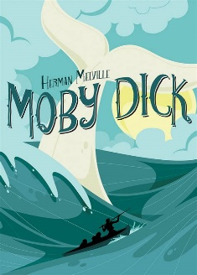 | 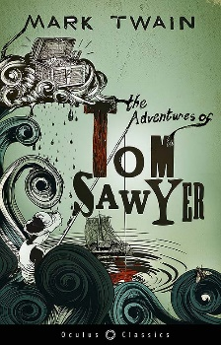
Frankenstein | Moby Dick | The Adventures of Tom Sawyer | The Valley of Fear

